# KENNECT QA ASSIGNMENT

## REPORT ON GOR -PATHJOLOGY LAB

Table of Contents

KENNECT QA ASSIGNMENT 1

ADDING PATIENTS: 2

TEST CALCULATOR: 4

VIEWING PATIENTS: 5

INVENTORY: 6

# ADDING PATIENTS:

* URL working on : <https://gor-pathology.web.app/patients>
* **Scenarios while adding patients** I used both automated and manual- blackbox testing of decision table:
  + Scenario 1: Trying to add patient with empty field of Phone number gives prompt of ‘**Required field’** warning- **Passed**
  + Scenario 2: Trying to add patient with empty field of Name number gives prompt of ‘**Patient Name is Required’** warning- **Passed**
  + Scenario 3: While giving negative age or giving invalid data to the fields for secondary fields gives appropriate waring- **Passed**
  + **BUGS:**
    - In test cost calculator from the list of available checklists the first checklist is undefined.
    - And if that option is clicked it redirects to some black web page.
    - If the checklist value ‘Beans’ is selected there are no options available to select from the available labs.

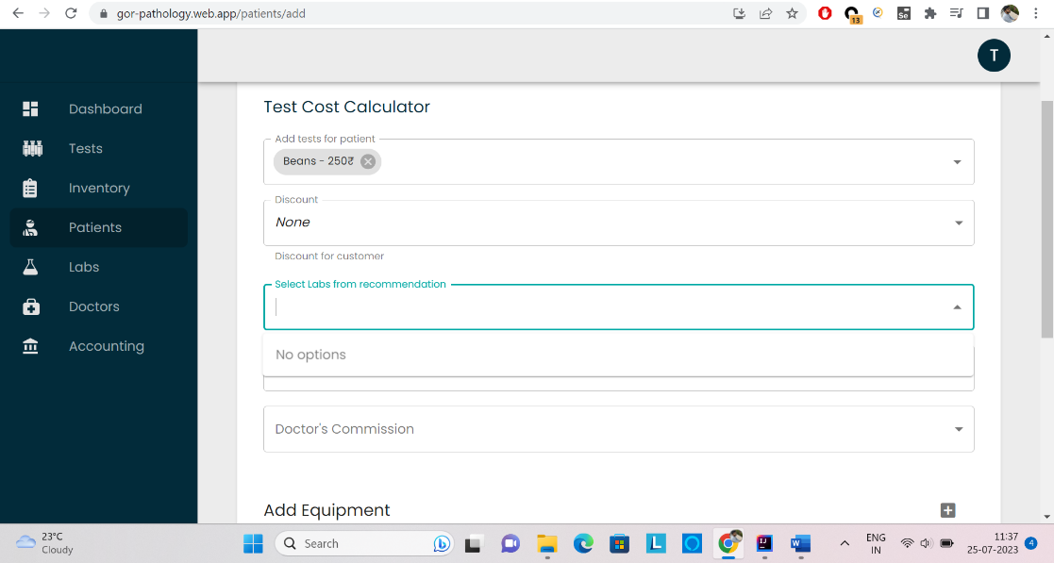

* + - Inappropriate names in the recommended checklist from the list of doctors. i.e., Beans
    - Showing zero 0 /- value for the lab Test Lab.

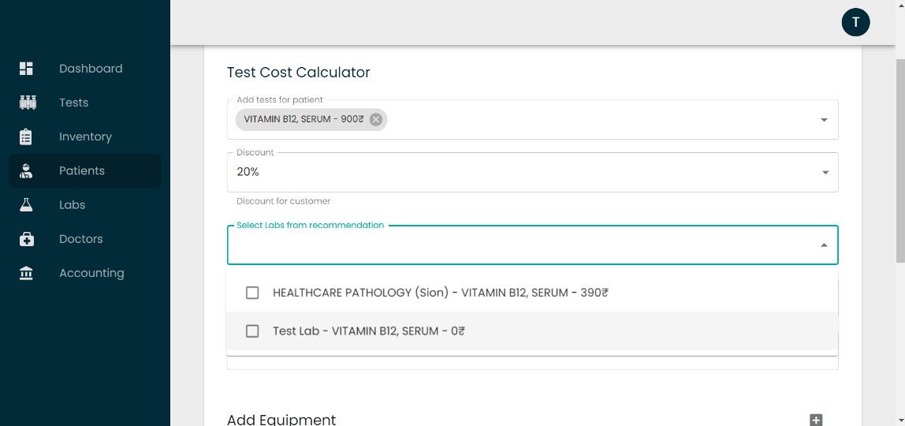

* + - No accurate name for the test equipment, shows one and only option i.e., test equipment.
    - Blank space under available lab option (not showing the no.of available equipments ), and user can able to add as many no.of equipments as he/she enters , which is not ideal.And after entering only it displays if its in stock or not.
    - Accepting the value for the required no.of equipment greater than the available in stock

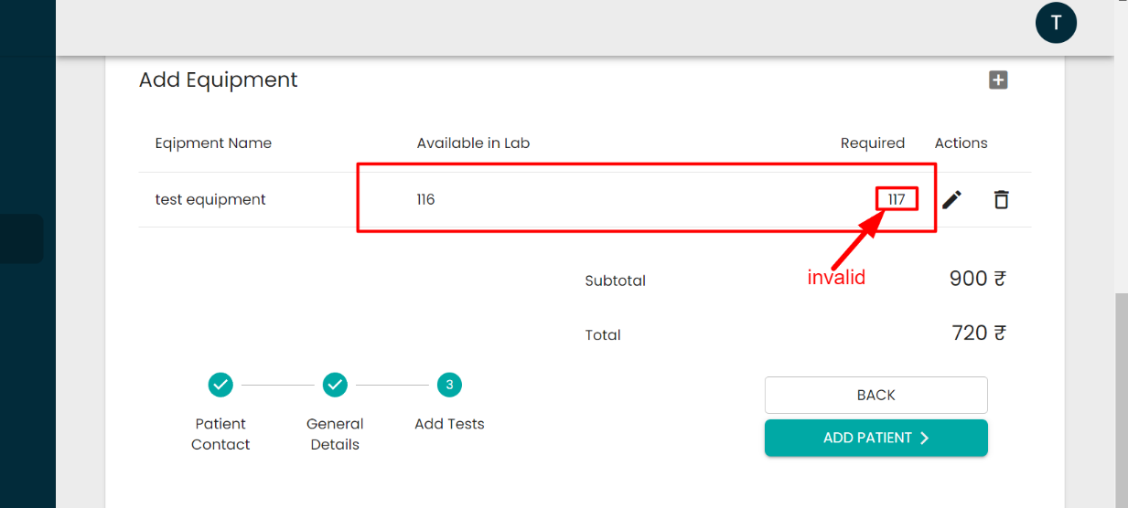

# TEST CALCULATOR:

* **Testing calculator** I used both automated and manual- blackbox testing:
  + **BUGS:**
    - Duplicate entries of the value ‘**Bean’** in the checklists of add test patients.
      * Steps to reproduce:
        + Login to the account
        + Click on patients button on the left side available options
        + Click on ‘ADD PATIENT’ button
        + Give primary and secondary details
        + Click on Add Test
        + Under Test Calculator click on add tests field
        + You can see multiple entries for the checklist ‘Beans’

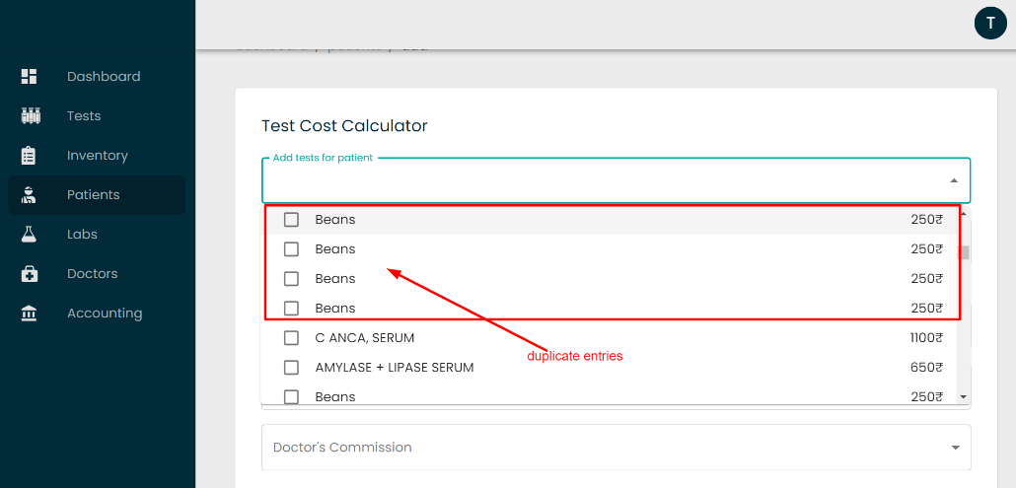

* + - From the list of available checklists the first checklist is undefined.

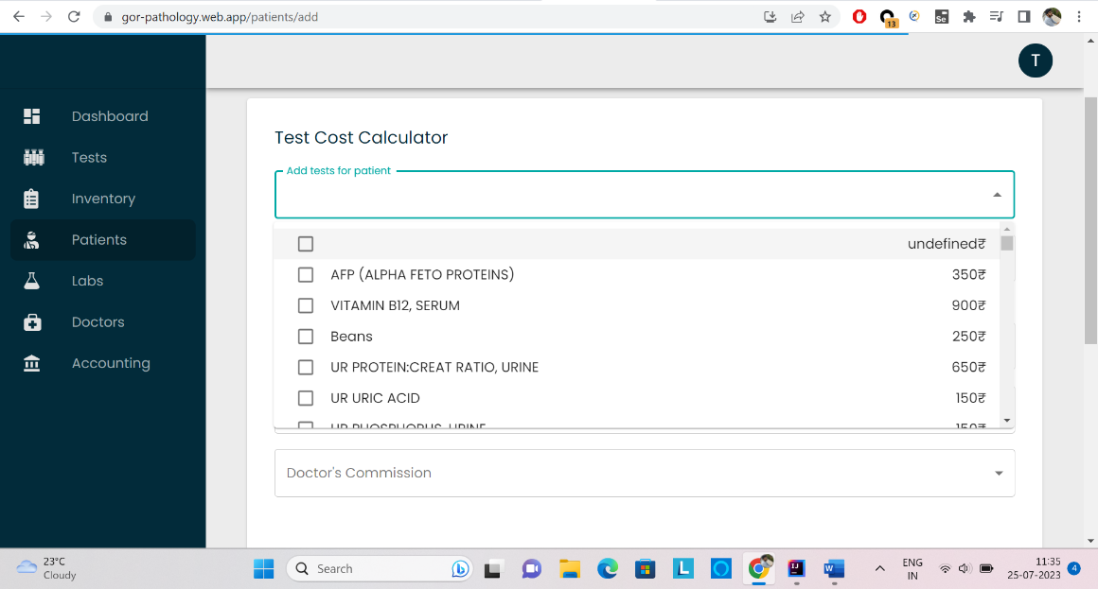

# VIEWING PATIENTS:

* + After successfully adding patients checked the details in the list of available patients – **Passed**
  + Filtering using name – **Passed**
  + Filtering using gender as ‘Female’ – **Passed**
  + **BUGS:**
    - Filter option under Gender is not functioning if typed as ‘**male**‘.
      * Steps to reproduce:
        + Login to the account
        + Go to the patients options button
        + Click on the filter option under Gender category
        + And type ‘male’

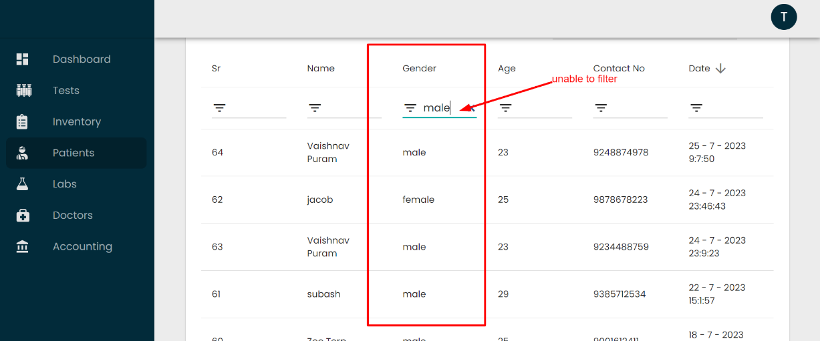

# INVENTORY:

* Able to edit the available equipments which is not a good option like there should be some authorization to be applied so that no common user can update the inventory.
* Steps to reproduce:
  + Login to the account
  + Click on the inventory option on left side of the available options.
  + Click on test equipment and click edit

